Aqua Evaluator for Individual Program Assessment (Taskstream replacement)

- To login to Aqua, go to the following URL. Use your BW email as login and the password you created or request a new password.
https://aqua.taskstream.com

- Select the projects assigned for the semester : You will receive the name of the project in your confirmation email.

- Click on Score Student Work on the left hand menu.

- Choose the course you are assessing on the Filter By option drop-down. The PAC will see all courses listed. The instructors will only see their courses they are assigned to assess.

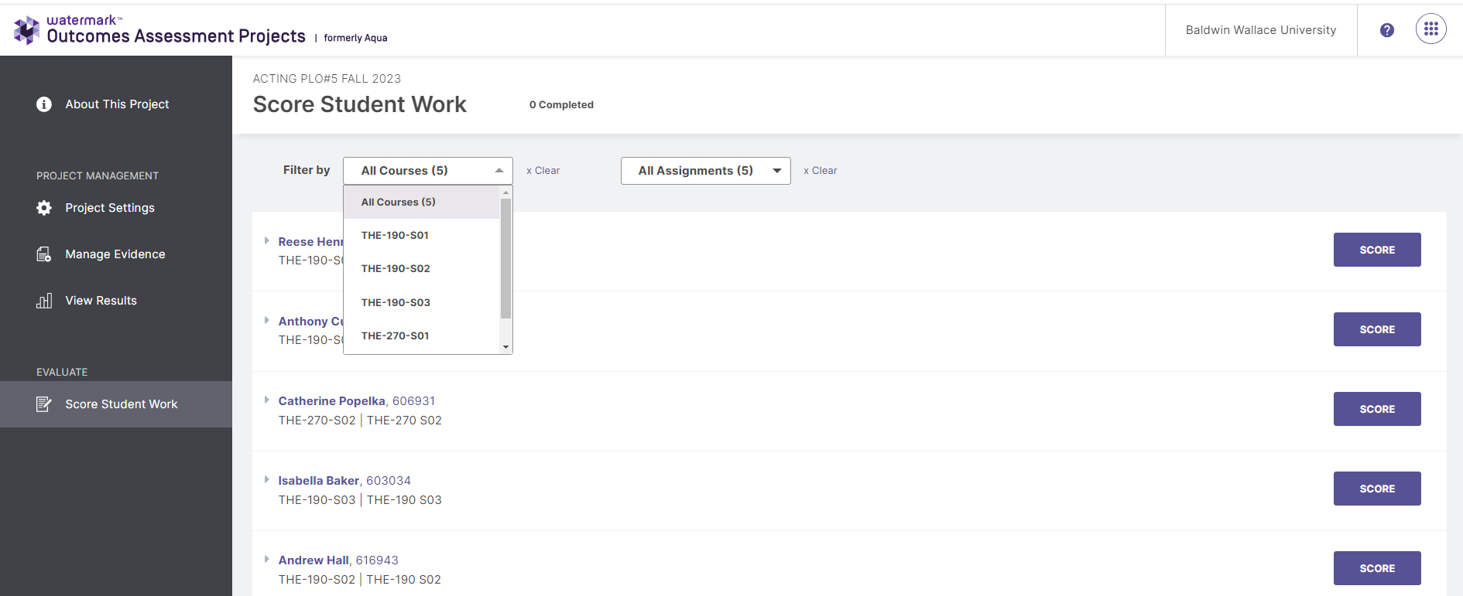

- Select REVIEW & Submit at the top right and the entire rubric will appear for you to complete.
You may choose a Detailed View at the upper right to see the descriptions for the criteria. Complete the rubric scores and select SUBMIT at the top right of the screen. That student will no longer be available in the queue to score.

- Select SUBMIT on upper right corner when rubric scores are completed.
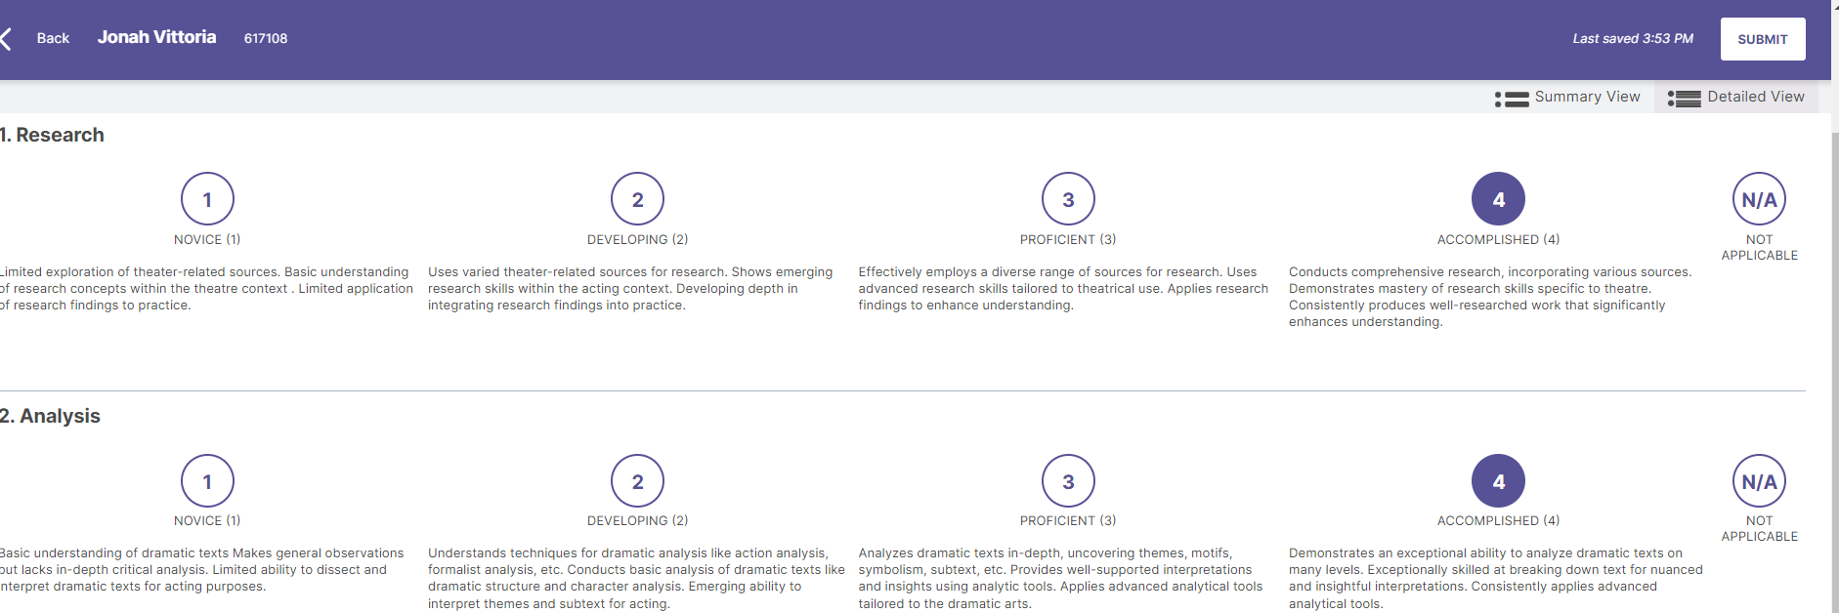

AQUA RESULTS VIEWING

Select VIEW RESULTS and choose the Learning Outcome you would like to report on using the drop down menu. Select Create Report.
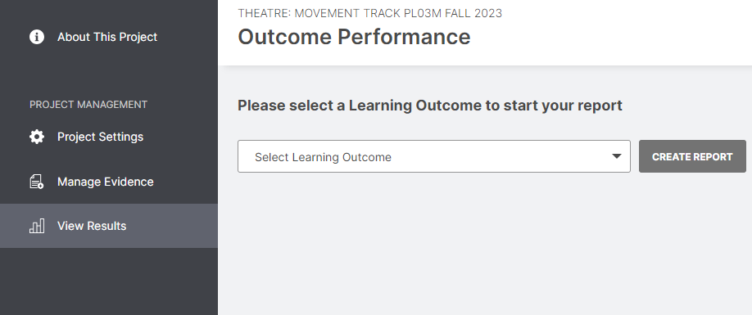

On this page you can view the means for each criterion and simply print PDF (right top corner) to save the graphs as a pdf. If you would like to filter on a demographic, choose the FILTERS option. You can also download the excel file if you would like to create your own charts.

