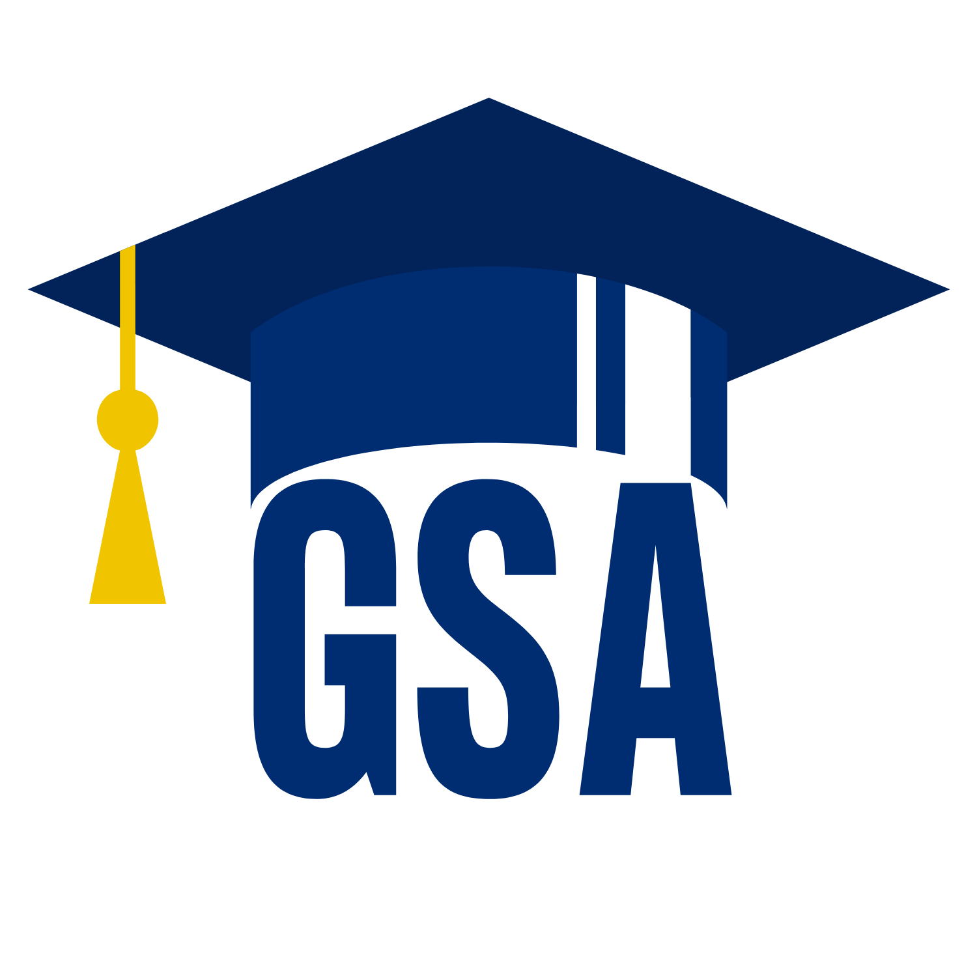October GSA Meeting 10. 11. 2023

- Approval of September Minutes
- Invited Speakers
  - Office of the Graduate Biomedical Education
- Executive Officer Announcements:
  - President (Rodney Eric Williams) & President-Elect (Scarlett Ge)
    - Cooley Center Updates
    - Graduate Coating Ceremony Information – Nov 1st
    - Convocation Speaker Survey – DUE Nov 1st
    - JH Public Safety requests feedback on JHPD Policies Due Nov 20th
      - Link to submit feedback
    - Flu Vaccines Open Oct 9th - Nov 15th No appointments neccessary!
      - Clinic info for East Baltimore Campus
    - JHU Admin requests feedback on JHU Policies regarding Climate Action and Sustainability Plan
      - Link to submit feedback
  - Director of Administration (Nirvani Jairam) - Juliane will be presenting
    - October Student Spotlight Winners
    - GSA Website 101 - https://jhu.campusgroups.com/gsa/home/
  - Director of Diversity, Inclusion, and Outreach (Ashley Chen)
    - Disability Awardness event with Student Disability Insurance
    - Updates on Future Information Sessions
    - East Baltimore feminine hygeine product placement updates
  - Director of Finance (Estefan Santi)
    - Travel Awards due Oct 15th Apply Now
  - Director of Social and Community Affairs (Mark Jacob)
    - Salsa Nights with Encanto Salsa DC
      - Register Now! Oct 10th , Oct 24th , & Nov 7th
    - BOO BASH Interschool Halloween Event
      - Oct 27th Grossi Plaza, 5 – 7:30 pm Register
    - Young Frankenstein Film Showing – Oct 31st Register
  - Director of Media and Public Relations (Juliane Liberto)
    - Allgrad listserv updates
    - B'more Fall Photo Contest – Ends Oct 20th Submission Form and Rules
  - Director of Student Involvment and Student Groups (Edna Ferreira)
    - Eboard + Council vote on funding request over $500
      - BSA – BrainFest
  - Director of Policy and Strategic Initiative (Nick Zhu)
    - GSA information session survery results
    - Updates to the GSAs Travel Award Application and Policy
- Program Representative Announcements
- Student Group Announcements
- University Committee Announcements
  - WLAC Updates from Estefan
- Misc. Announcements

Please Join our newly launched Hopkins Groups Page!!!

Follow the GSA on social media platforms for up-to-date information about events and other important announcements!
JHopkinsMedicineGSA jhmi.gsa jhmi_gsa

