Student Government Association and Student Bar Association
Safety Plan SQ 2023
Event: Therapy Dogs- Week 7
Date: Thursday, June 1st, 2023
Time: 11:30 pm-13:30 pm
Location: Loop Rooftop “Terrace/Deck”
Key mentions: Animals (Therapy Dogs)

Vendor: Alliance of Therapy Dogs (Tentative)
Purpose of Event: To provide students an opportunity to destress before finals week as part of our mission statement to serve the community.

Safety Plan
- Handler/dog teams will be escorted from agreed meeting location to the event location by authorized staff members only. Teams must be transported to floors using maintenance elevators only. Refer to Figures 1 and 2 for team transportation inside buildings.
- Refer to Figure 3 for detailed layout of event space.
- Handlers will hold the leash of their therapy dogs at all times. Handlers and dogs will be given space to take breaks and destress as often as handler and dogs need. Handler will have the final say regarding the extent their dog interacts with guests.
- Before entering space, guests will be made aware (verbally by staff members and visually by welcome posters and posters posted around handler/dog rest areas) to respect handler and dog space in event space and outside of event space.
- Guests will be required to sign an electronic waiver on DeHub prior to participating in the event. Guests who complete the waiver will have their hand stamped so each volunteer knows they are approved to engage with the animal.
- Guests will need to sanitize their hands before and after engaging with the dogs.
- Handlers and staff members will be there to answer questions about the therapy dog, provide participants instructions for handling/petting, and clean up any waste.
- There will be only one entrance to the event space to regulate the influx of visitors. There will be one exit.
- Staff members will walk around to ensure handler/dog and participant enjoyment and safety. There will be a zero-tolerance for inappropriate behavior. Participants displaying inappropriate behavior will be asked to leave. Campus Safety will be contacted for non-complying individuals.
- A maximum of 10 guests per handler/dog team will be allowed unless otherwise stated by the handler (signs will be displayed on the maximum number of guests per handler/dog team not exceeding 10). Participants will be allowed 5-7 minutes per petting session.
- Campus Safety will be notified no less than one week in advance of event.
- Handler/dog teams will be spaced at least two feet apart unless otherwise stated by the Handlers.
- A basic first aid kid will be on-site.
- All animal waste will be cleaned up immediately.
- Handlers will be expected to adhere to the Alliance of Therapy Dogs Rules and Regulations: https://www.therapydogs.com/wp-content/uploads/2022/11/2023-Rules.pdf

SGA and SBA members will be responsible for leaving the space as it was found after the event ends.

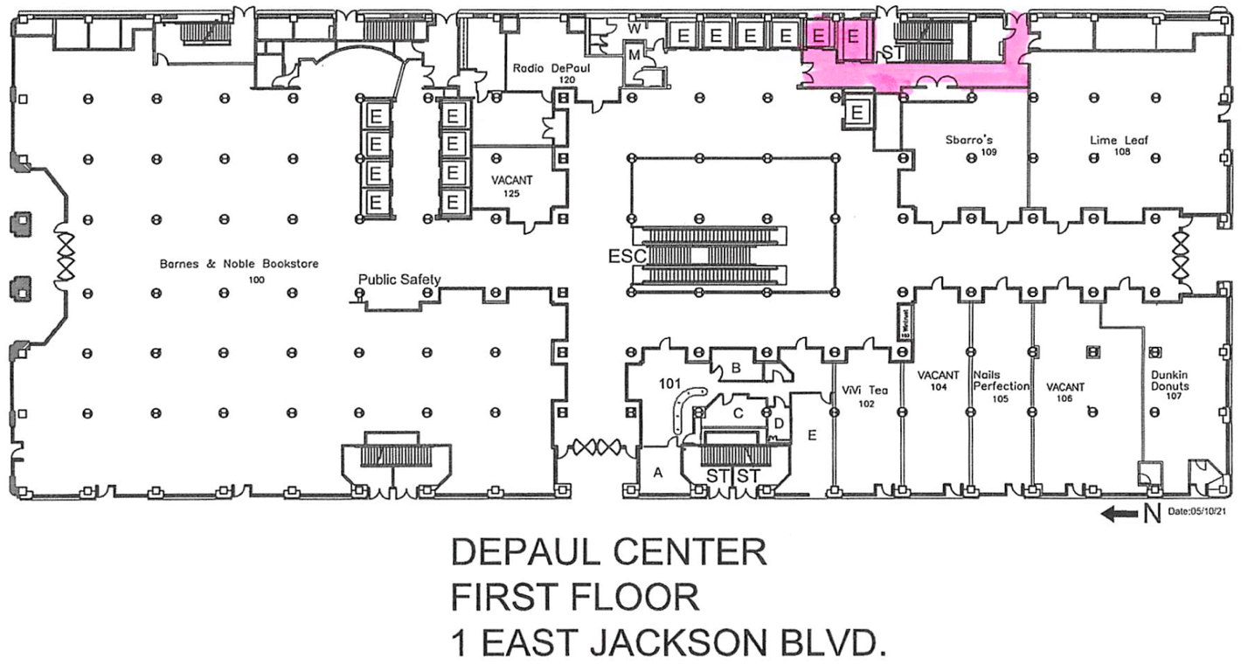
Figure 1. Route of entrance of therapy dog teams into DePaul Center’s first floor, highlighted in pink.

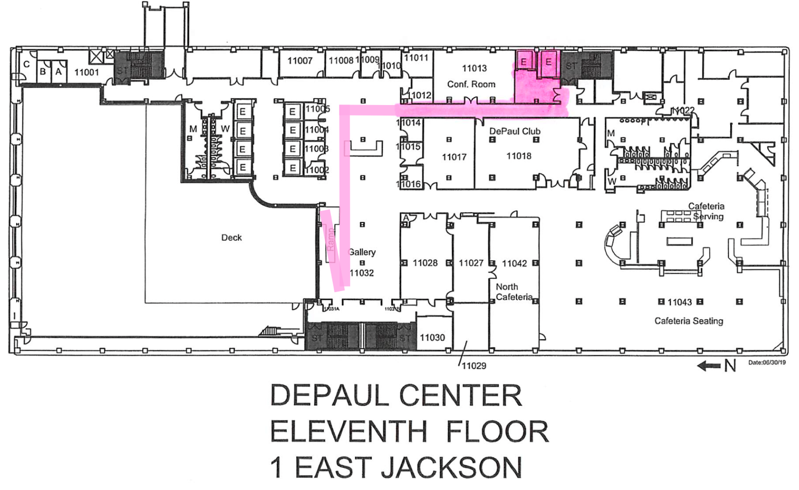
Figure 2. Route of route of therapy dog teams from service elevators to the Terrace/Deck on the 11th floor of DePaul Center, highlighted in pink.

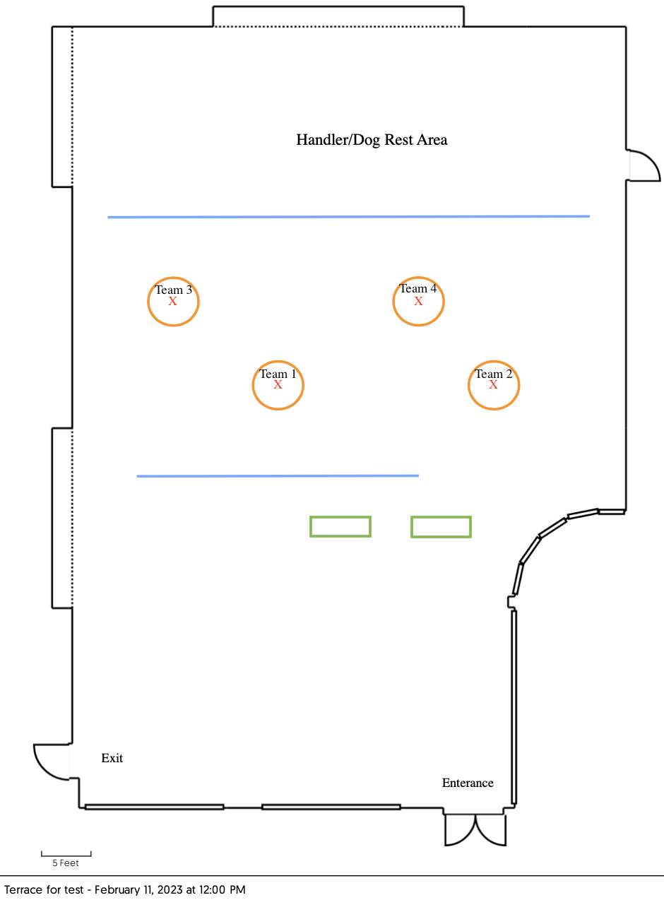
Figure 3. Loop Rooftop planned layout for SQ Therapy Dog Event 2023. Green rectangles detail 6’ check-in tables. Orange circles represent areas where handler/dog teams will interact with participants. Red “X”s represent chairs. Blue lines represent space separators.

