College of Science and Health Student Association and Student Government Association
Safety Plan AQ 2022
Event: Therapy Dogs- Week 10
Date: Monday, November 14, 2022
Time: 1:00pm-3:00pm
Location: Quad
Key mentions: Animals

Vendor: Medinah Shriners Therapy Dog Club
Purpose of Event: To provide students an opportunity to destress before finals week as part of our mission statement to serve the (CSH) community.

Safety Plan
Key mentions: Animals (therapy dogs)
- Handlers will hold the leash of their therapy dogs at all times. Handlers and dogs will be given space to take breaks and destress as often as handler and dogs need. Handler will have the final say regarding the extent their dog interacts with guests.
- Before entering space, guests will be made aware (verbally by CSHSA members and visually by welcome posters and posters posted around handler/dog rest areas) to respect handler and dog space in event space and outside of event space.
- Guests will be required to sign a waiver prior to participating in the event. Guests who complete the waiver will have their hand stamped so each volunteer knows they are approved to engage with the animal.
- Guests will need to sanitize their hands before and after engaging with the dogs.
- Handlers and CSHSA members will be there to answer questions about the therapy dog, provide participants instructions for handling/petting, and clean up any waste.
- If the event is to be held in Quad, there will be only one entrance to the event to regulate the influx of visitors.
- CSHSA Members will walk around to ensure handler/dog and participant enjoyment and safety. There will be a zero-tolerance for inappropriate behavior. Participants displaying inappropriate behavior will be asked to leave. Campus Safety will be contacted for non-complying individuals.
- A maximum of 10 guests per handler/dog team will be allowed unless otherwise stated by the handler (signs will be displayed on the maximum number of guests per handler/dog team not exceeding 10). Participants will be allowed 5-7 minutes per petting session.
- Spring: the Quad will have spaces for participants to participate but not interact with the therapy dogs. See Figure 1 on page 2 for planned layout for the Quad.
- Campus Safety will be notified no less than one week in advance of event.
- Handler/dog teams will be spaced 10-15 ft apart.
- A basic first aid kid will be on-site.
- All animal waste will be cleaned up immediately.

The CSHSA members will be responsible for leaving the space as it was found after the event ends.
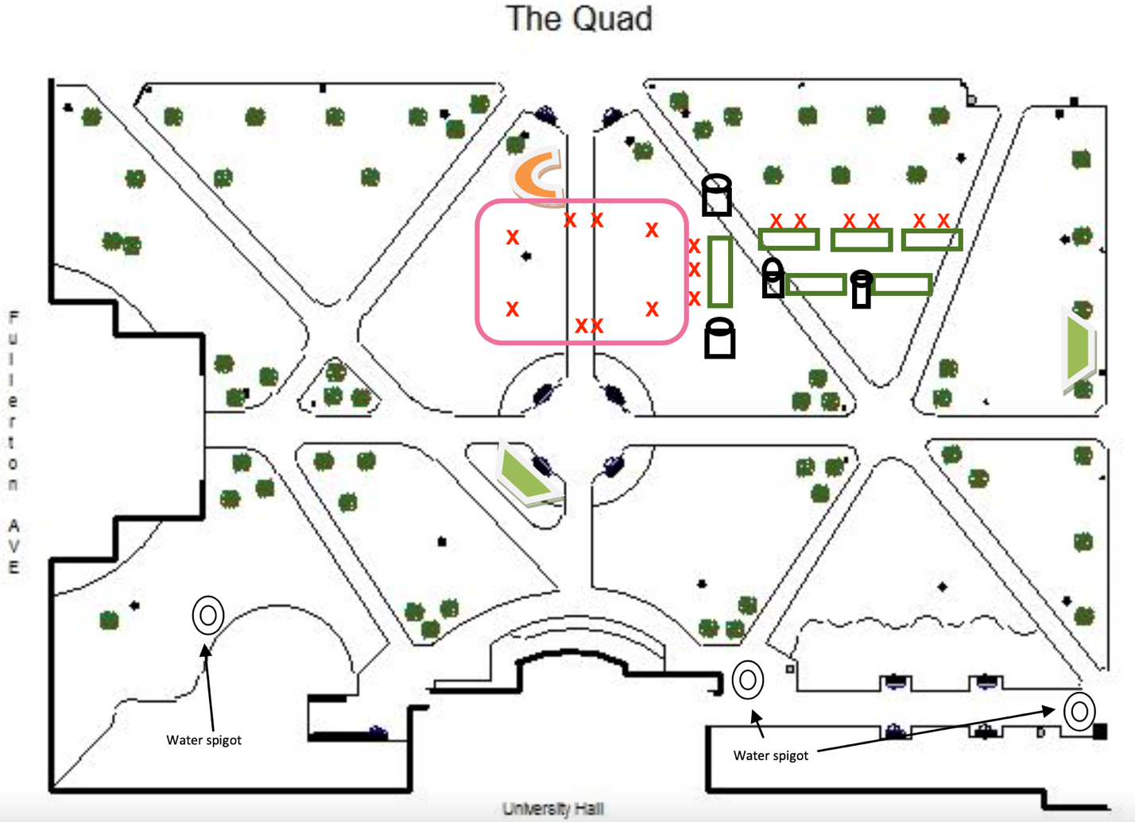
Figure 1. Quad planned layout for AQ Therapy Dog Event 2022 CSHSA. Center pink rectangle details the event tent area where participants and handler/dog teams will interact. Black rectangles with ovals on top are represent trash cans. Dark green rectangles indicate 6’ tables. Red “X”s represent chairs. All other shapes represent preset landmarks on the Quad.

