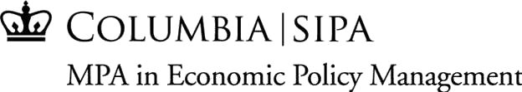

MPA-EPM Student Assistant – April 26- August 31, 2021
Job Description: The MPA in Economic Policy Management program out of Columbia University’s School of International and Public Affairs is seeking a Student Assistant for April 26-August 31(MPA-EPM SUMMER TERMS) . The Program Assistant will work with our Program Assistant and Student Services Coordinator on various projects throughout the summer. Tasks include, but are not limited to administrative assistance, promotional material design, mass email outreach, website content management, and ad hoc projects as needed.
Desired Skills:
- Some minor design skills may be required, including experience with Photoshop, PowerPoint, or similar software to aid in design.
- Excellent writing skills are a must, as is experience with common office software such as Microsoft Word, Excel, PowerPoint, etc. Strong attention to detail is also a must.
- Knowledge of mass communications platforms, such as Mailchimp
- Knowledge of social media platforms (Facebook, Twitter, LinkedIn, etc.) is also a plus, especially skills in managing professional social media accounts.
- Interest in economics and/or economic policy is preferred but not required.

About the Position:
- Compensation: $15 per hour
- Hours: Approx. 8-15 hours per week
- Timeframe: MPA_EPM SUMMER TERMS (April 26 – August 31), with the possibility to continue into Fall
- Report to: Student Services Coordinator and Assistant Director
- Work-study eligibility is required
To apply : Please send a resume and short cover letter to mpa-epm@columbia.edu .
About MPA-EPM: The MPA-EPM provides leading policymakers and professionals with the skills to effectively design and implement economic policy in market economies, with a strong emphasis on the economic problems of developing countries. Students in the one-year MPA-EPM program gain the skills they need to become highly accomplished policymakers and professionals in market economies. The course of study applies the theoretical rigor of the social sciences to the practical lessons of economics and management science through the intensive study of actual economic policy successes and failures. To learn more about the MPA in Economic Policy Management, please visit https://sipa.columbia.edu/academics/programs/mpa-economic-policy-management

